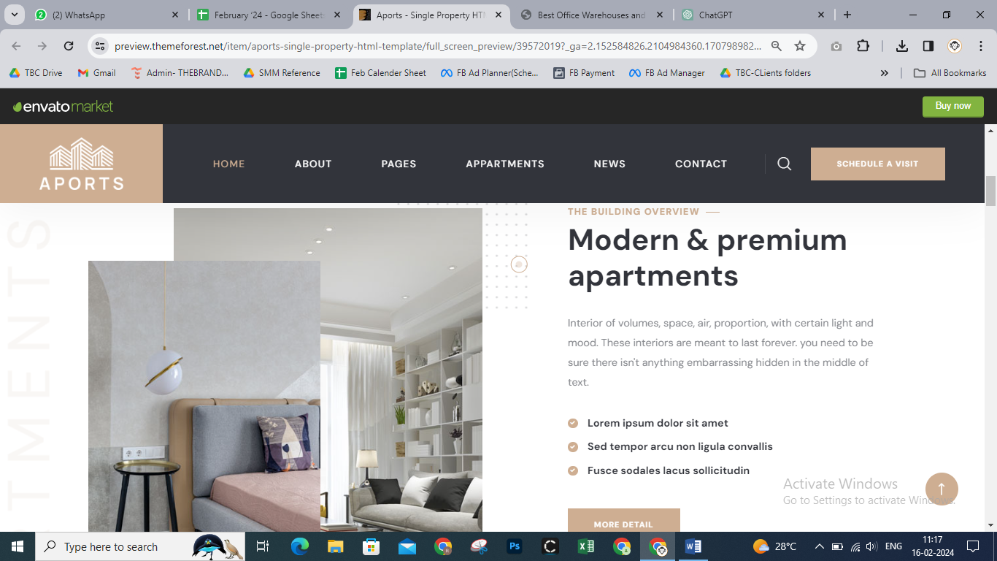
PRIME OFFICE WAREHOUSES
Transforming Workspaces in Lewisville, Texas.
Located at Leora Ln & E State Hwy 121 in Lewisville, Texas 75067, Prime Office Warehouses offer a distinctive blend of warehouse, retail, and office spaces. Each unit boasts a welcoming storefront ambiance, inviting customers with a retail-like experience.
-Customize each unit for office or warehouse use.
-Adaptable open floor plans cater to diverse business needs.
-Tailor your space to suit your requirements precisely.
More Details -> View Flyer
72,400 sft – Project Size
4.10 – Acres
98 – Total Units
22 – Available Units
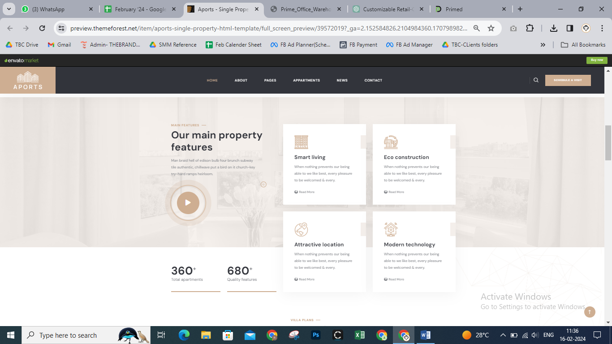
PROJECT HIGHLIGHTS
Versatile Spaces For Your Business
With 72,000 sq ft of office space across two buildings, Prime Office Warehouses offers diverse options. Located on Highway 121, Leora Lane, with over 125,000 daily vehicles, it's a prime spot in the growing Dallas Fort Worth Area.
-Traffic: High traffic volume and extended road frontage.
-Utilities: On-site availability of electricity, water and parking space.
-Access: Proximity to Leander's South San Gabriel River Park.
-Location: Traffic counts along U.S. Route 183 exceed 23,000 vehicles.
294,512 sft – Total Building Size
2,607 sft – Typical Floor Size
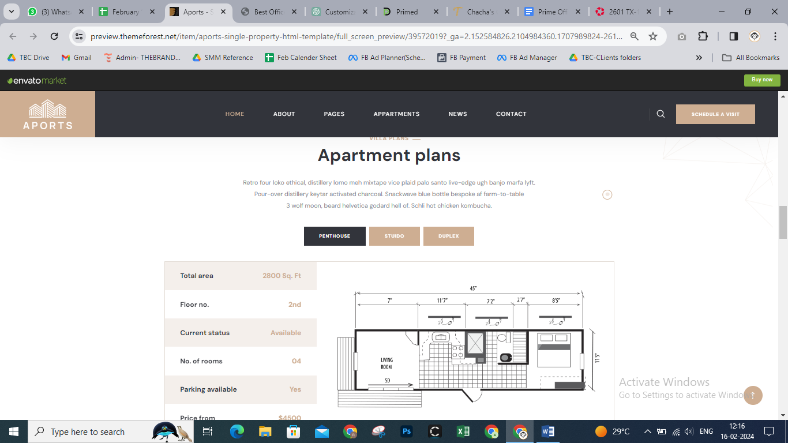
BUILDING 6 & 7
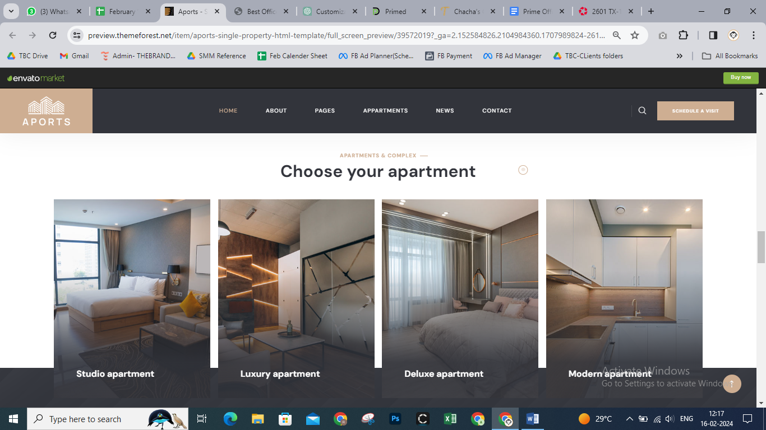
ESTABLISHED SITES
Transforming Properties Into Unique Visions

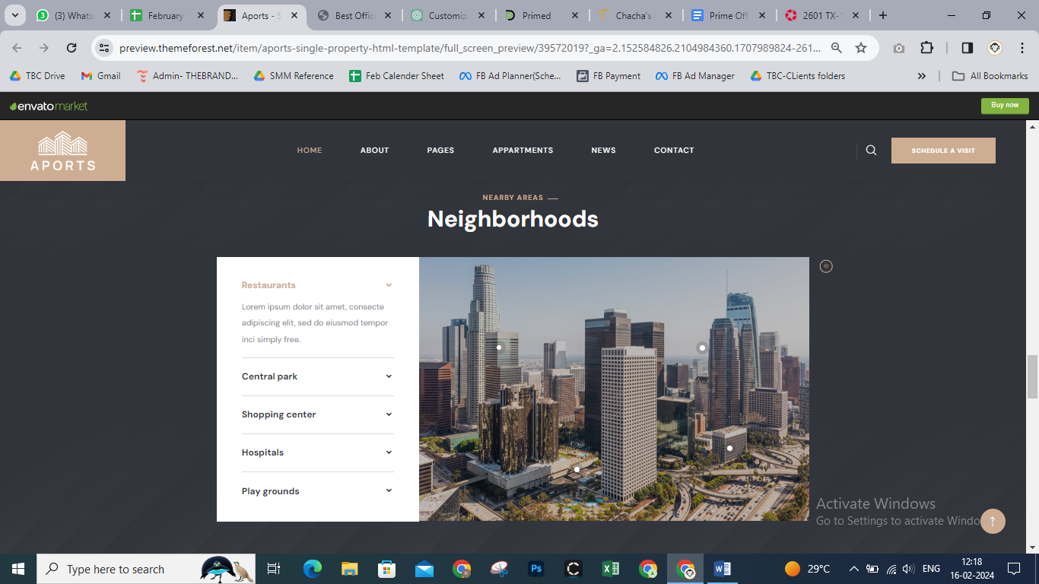
NEAR BY AREAS
Neighborhoods
Castle Hills Residential Community
Walmart Super Centre Lewisville
Nebraska Furniture Mart
The Colony High School
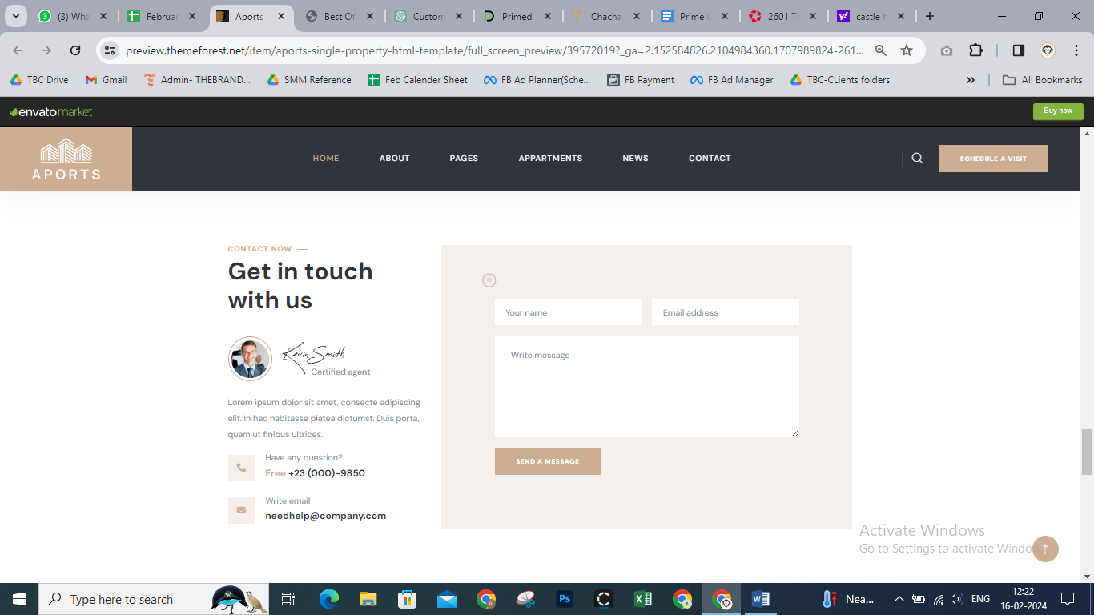
CONTACT NOW
Get In Touch With Us
Mallik Gilakattula (his sign)

Ready to find your ideal workspace?
Contact us today to explore our versatile office options in the heart of the bustling Dallas Fort Worth Area!

Have Any Questions – 512-761-8025
Write An Email – mallik@theprimedeveloper.com

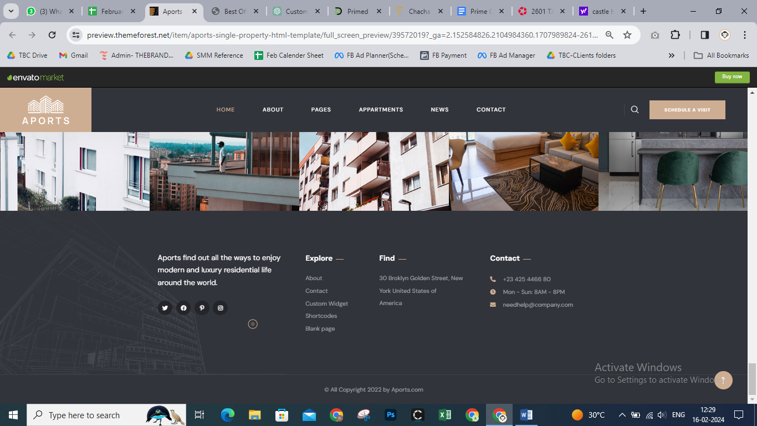

Discover Prime Office Warehouses: a dynamic mixed-use development offering versatile spaces tailored to modern business needs.
Find - Leora Ln & E state Hwy 121, Lewisville, Texas 75067.
Contact –
Number is mentioned already.
Mail – info@theprimedeveloper.com (have this one added here)

